NUMERICAL METHODS ASSIGNMENT
1. SECANT METHOD
Question: Use the Secant Method to solve f(x) = x³ − x − 2 = 0, taking x₀ = 1 and x₁ = 2. Use a tolerance of 10⁻⁶.
Formula: xᵢ₊₁ = xᵢ − f(xᵢ)(xᵢ − xᵢ₋₁) / [f(xᵢ) − f(xᵢ₋₁)]
Substitution for the first iteration:
f(1) = −2, f(2) = 4
x₂ = 2 − 4(2−1)/(4−(−2)) = 1.333333
Repeating the process gives:
i | xᵢ₋₁ | xᵢ | f(xᵢ₋₁) | f(xᵢ) | xᵢ₊₁ | f(xᵢ₊₁)
1 | 1.00000000 | 2.00000000 | -2.00000000 | 4.00000000 | 1.33333333 | -0.96296296
2 | 2.00000000 | 1.33333333 | 4.00000000 | -0.96296296 | 1.46268657 | -0.33333887
3 | 1.33333333 | 1.46268657 | -0.96296296 | -0.33333887 | 1.53116943 | 0.05862642
4 | 1.46268657 | 1.53116943 | -0.33333887 | 0.05862642 | 1.52092642 | -0.00269330
5 | 1.53116943 | 1.52092642 | 0.05862642 | -0.00269330 | 1.52137632 | -0.00002015
6 | 1.52092642 | 1.52137632 | -0.00269330 | -0.00002015 | 1.52137971 | 0.00000001
Therefore, the root is approximately x = 1.5213797.

Secant pseudocode
START
Input x0, x1, tolerance and maximum iterations
FOR i = 1 to maximum iterations
Calculate x2 using the Secant formula
IF |f(x2)| < tolerance
Output x2
STOP
END IF
x0 = x1
x1 = x2
END FOR
Output x2
STOP

MATLAB: Secant Method using FOR loop
clc; clear;
f = @(x) x^3 - x - 2;
x0 = 1; x1 = 2;
tol = 1e-6; maxit = 20;
for i = 1:maxit
x2 = x1 - f(x1)*(x1-x0)/(f(x1)-f(x0));
fprintf('%d %.8f\n',i,x2);
if abs(f(x2)) < tol
break
end
x0 = x1;
x1 = x2;
end
fprintf('Root = %.8f\n',x2);

MATLAB: Secant Method using WHILE loop
clc; clear;
f = @(x) x^3 - x - 2;
x0 = 1; x1 = 2;
tol = 1e-6; maxit = 20;
i = 0; err = inf;
while i < maxit && err > tol
i = i + 1;
x2 = x1 - f(x1)*(x1-x0)/(f(x1)-f(x0));
err = abs(f(x2));
fprintf('%d %.8f\n',i,x2);
x0 = x1;
x1 = x2;
end
fprintf('Root = %.8f\n',x2);
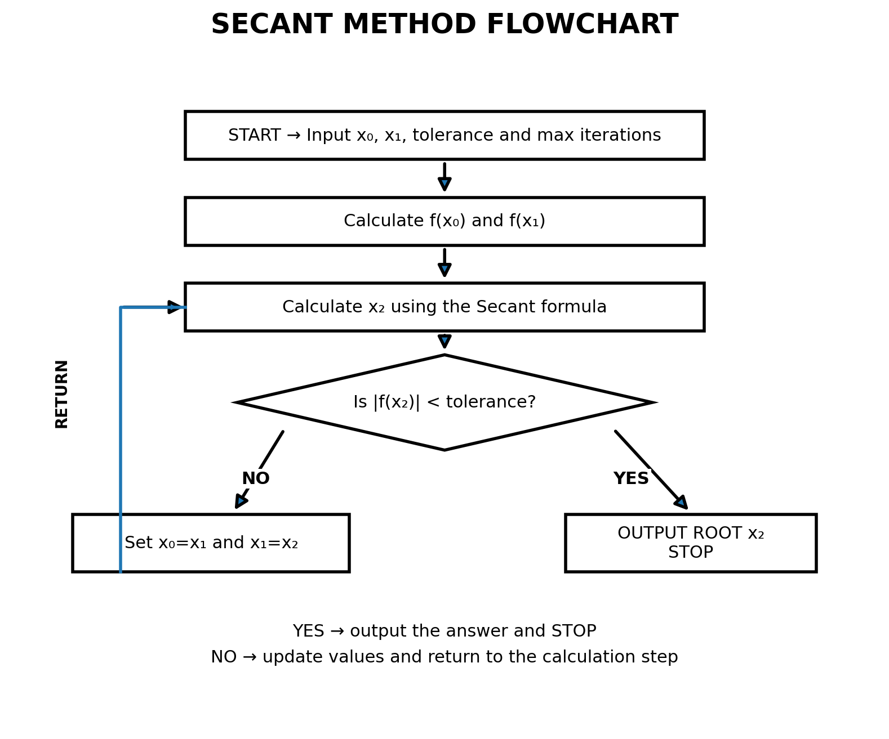

2. NEWTON-RAPHSON METHOD
Question: Use the Newton-Raphson Method to solve x² − 5 = 0, starting with x₀ = 2. Use a tolerance of 10⁻⁶.
Let f(x)=x²−5 and f′(x)=2x.
Newton-Raphson formula: xᵢ₊₁ = xᵢ − f(xᵢ)/f′(xᵢ)
First iteration:
x₁ = 2 − (2²−5)/(2×2) = 2.25
i | xᵢ | f(xᵢ) | f′(xᵢ) | xᵢ₊₁ | f(xᵢ₊₁)
1 | 2.00000000 | -1.00000000 | 4.00000000 | 2.25000000 | 0.06250000
2 | 2.25000000 | 0.06250000 | 4.50000000 | 2.23611111 | 0.00019290
3 | 2.23611111 | 0.00019290 | 4.47222222 | 2.23606798 | 0.00000000
Therefore, the positive root is x = √5 ≈ 2.23606798.

Newton-Raphson pseudocode
START
Input x0, tolerance and maximum iterations
FOR i = 1 to maximum iterations
Calculate f(x0) and f'(x0)
x1 = x0 - f(x0)/f'(x0)
IF |f(x1)| < tolerance
Output x1
STOP
END IF
x0 = x1
END FOR
Output x1
STOP

MATLAB: Newton-Raphson using FOR loop
clc; clear;
f = @(x) x^2 - 5;
df = @(x) 2*x;
x0 = 2;
tol = 1e-6; maxit = 20;
for i = 1:maxit
x1 = x0 - f(x0)/df(x0);
fprintf('%d %.8f\n',i,x1);
if abs(f(x1)) < tol
break
end
x0 = x1;
end
fprintf('Root = %.8f\n',x1);

MATLAB: Newton-Raphson using WHILE loop
clc; clear;
f = @(x) x^2 - 5;
df = @(x) 2*x;
x0 = 2;
tol = 1e-6; maxit = 20;
i = 0; err = inf;
while i < maxit && err > tol
i = i + 1;
x1 = x0 - f(x0)/df(x0);
err = abs(f(x1));
fprintf('%d %.8f\n',i,x1);
x0 = x1;
end
fprintf('Root = %.8f\n',x1);
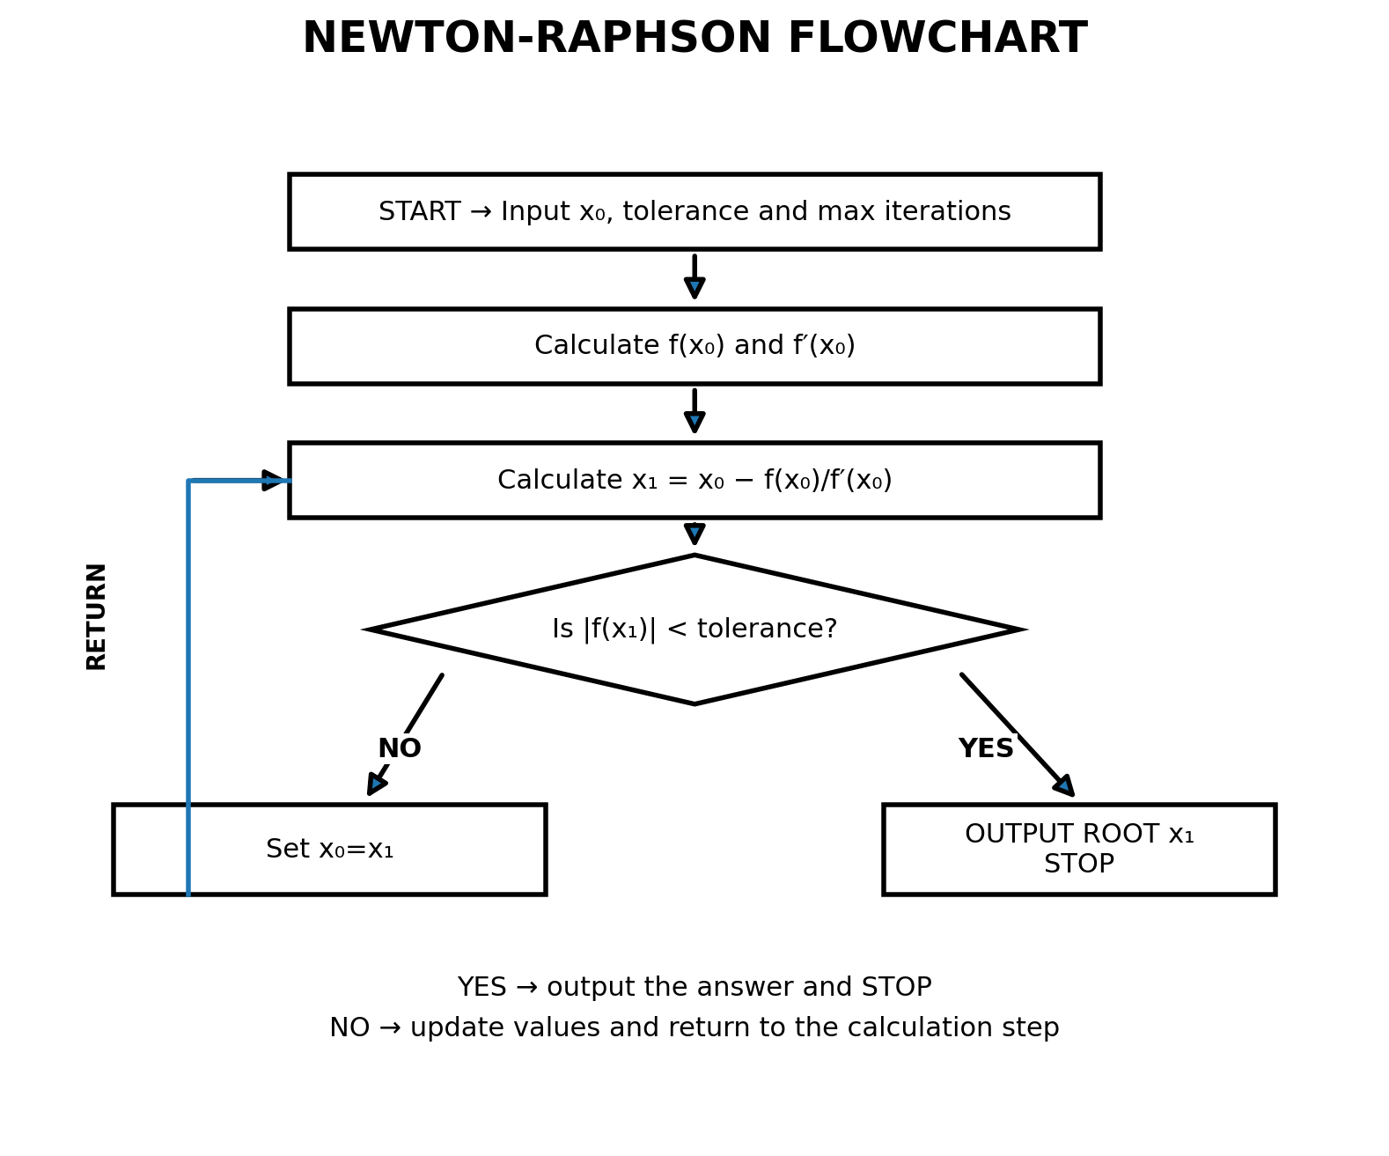

3. FOURTH-ORDER RUNGE-KUTTA (RK4) METHOD
Question: Use the fourth-order Runge-Kutta method to estimate y(0.3) for dy/dx = x + y, with y(0) = 1 and step size h = 0.1.
RK4 formulas:
k₁ = h f(xₙ,yₙ)
k₂ = h f(xₙ+h/2, yₙ+k₁/2)
k₃ = h f(xₙ+h/2, yₙ+k₂/2)
k₄ = h f(xₙ+h, yₙ+k₃)
yₙ₊₁ = yₙ + (k₁ + 2k₂ + 2k₃ + k₄)/6
For the first step, x₀=0 and y₀=1:
k₁ = 0.1(0+1) = 0.100000
k₂ = 0.1(0.05+1.05) = 0.110000
k₃ = 0.1(0.05+1.055) = 0.110500
k₄ = 0.1(0.1+1.1105) = 0.121050
y₁ = 1 + (0.1 + 2(0.11) + 2(0.1105) + 0.12105)/6 = 1.11034167
Step | xₙ | yₙ | k₁ | k₂ | k₃ | k₄ | xₙ₊₁ | yₙ₊₁
1 | 0.00000000 | 1.00000000 | 0.10000000 | 0.11000000 | 0.11050000 | 0.12105000 | 0.10000000 | 1.11034167
2 | 0.10000000 | 1.11034167 | 0.12103417 | 0.13208588 | 0.13263846 | 0.14429801 | 0.20000000 | 1.24280514
3 | 0.20000000 | 1.24280514 | 0.14428051 | 0.15649454 | 0.15710524 | 0.16999104 | 0.30000000 | 1.39971699
Hence, y(0.3) ≈ 1.39971762.

Runge-kutta pseudocode
START
Input x0, y0, h and final x
WHILE x0 < final x
k1 = h*f(x0,y0)
k2 = h*f(x0+h/2,y0+k1/2)
k3 = h*f(x0+h/2,y0+k2/2)
k4 = h*f(x0+h,y0+k3)
y1 = y0 + (k1+2*k2+2*k3+k4)/6
x0 = x0 + h
y0 = y1
END WHILE
Output y0
STOP

MATLAB: Runge-kutta using FOR loop
clc; clear;
f = @(x,y) x + y;
x = 0; y = 1;
h = 0.1; n = 3;
for i = 1:n
k1 = h*f(x,y);
k2 = h*f(x+h/2,y+k1/2);
k3 = h*f(x+h/2,y+k2/2);
k4 = h*f(x+h,y+k3);
y = y + (k1+2*k2+2*k3+k4)/6;
x = x + h;
fprintf('%d x=%.1f y=%.8f\n',i,x,y);
end
fprintf('y(0.3) = %.8f\n',y);

MATLAB: Runge-kutta using WHILE loop
clc; clear;
f = @(x,y) x + y;
x = 0; y = 1;
h = 0.1; xend = 0.3;
i = 0;
while x < xend
i = i + 1;
k1 = h*f(x,y);
k2 = h*f(x+h/2,y+k1/2);
k3 = h*f(x+h/2,y+k2/2);
k4 = h*f(x+h,y+k3);
y = y + (k1+2*k2+2*k3+k4)/6;
x = x + h;
fprintf('%d x=%.1f y=%.8f\n',i,x,y);
end
fprintf('y(0.3) = %.8f\n',y);
